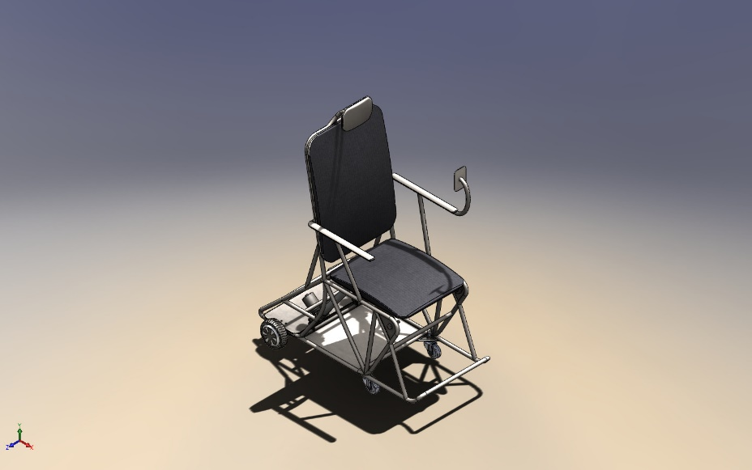 | Simulation of Assem4  Date: Sunday, January 12, 2025  Designer: Solidworks  Study name: Static 4  Analysis type: Static  Table of Contents  Description 1  Material Properties 2  Connector Definitions 4  Mesh information 8  Study Results 9  Conclusion 12

Description
No Data

Material Properties
Model Reference | Properties | Components
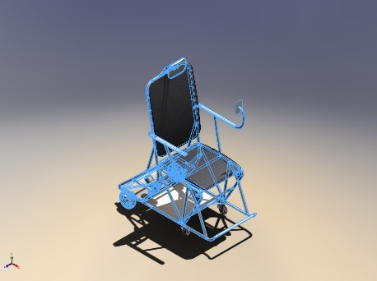 | Name: 1023 Carbon Steel Sheet (SS)  Model type: Linear Elastic Isotropic  Default failure criterion: Max von Mises Stress  Yield strength: 2.82685e+08 N/m^2  Tensile strength: 4.25e+08 N/m^2  Elastic modulus: 2.05e+11 N/m^2  Poisson's ratio: 0.29  Mass density: 7,858 kg/m^3  Shear modulus: 8e+10 N/m^2  Thermal expansion coefficient: 1.2e-05 /Kelvin | SolidBody 1(Cut-Extrude5)(Back-1),  SolidBody 1(Cut-Extrude8)(Iteration4_chassis-1),  SolidBody 2(Mirror50)(Iteration4_chassis-1),  SolidBody 3(Fillet33)(Iteration4_chassis-1),  SolidBody 4(Boss-Extrude33)(Iteration4_chassis-1),  SolidBody 1(Motor, BLDC, Hoverboard Wheel, 6.5in.stp<1>)(Motor, BLDC, Hoverboard Wheel, 6.5in.stp-1),  SolidBody 1(Motor, BLDC, Hoverboard Wheel, 6.5in.stp<1>)(Motor, BLDC, Hoverboard Wheel, 6.5in.stp-2),  SolidBody 1(Chamfer4)(RS.177-4516-3000N-1/RS.177-4516-bottom-1),  SolidBody 1(Chamfer2)(RS.177-4516-3000N-1/RS.177-4516-bottom-mount-1),  SolidBody 1(Chamfer4)(RS.177-4516-3000N-2/RS.177-4516-bottom-1),  SolidBody 1(Chamfer2)(RS.177-4516-3000N-2/RS.177-4516-bottom-mount-1),  SolidBody 1(Fillet5)(butt_cushion_v2-1),  SolidBody 1(HeadChamfer)(heavy hex bolt_am-2),  SolidBody 1(HeadChamfer)(heavy hex bolt_am-3)
Curve Data:N/A
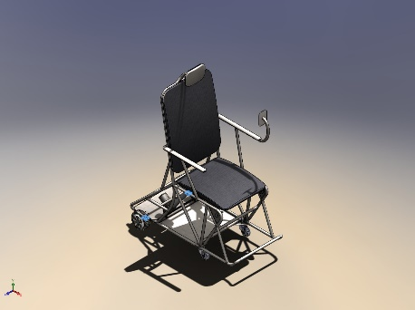 | Name: Cast Alloy Steel  Model type: Linear Elastic Isotropic  Default failure criterion: Max von Mises Stress  Yield strength: 2.41275e+08 N/m^2  Tensile strength: 4.48083e+08 N/m^2  Elastic modulus: 1.9e+11 N/m^2  Poisson's ratio: 0.26  Mass density: 7,300 kg/m^3  Shear modulus: 7.8e+10 N/m^2  Thermal expansion coefficient: 1.5e-05 /Kelvin | SolidBody 1(Fillet2)(Hub Motor Shaft Bracket-1),  SolidBody 1(Fillet2)(Hub Motor Shaft Bracket-2)
Curve Data:N/A
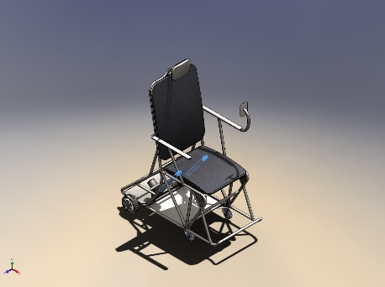 | Name: 1060 Alloy  Model type: Linear Elastic Isotropic  Default failure criterion: Unknown  Yield strength: 2.75742e+07 N/m^2  Tensile strength: 6.89356e+07 N/m^2  Elastic modulus: 6.9e+10 N/m^2  Poisson's ratio: 0.33  Mass density: 2,700 kg/m^3  Shear modulus: 2.7e+10 N/m^2  Thermal expansion coefficient: 2.4e-05 /Kelvin | SolidBody 1(Cut-Extrude1)(RS.177-4516-3000N-1/RS.177-4516-shaft-1),  SolidBody 1(Boss-Extrude2)(RS.177-4516-3000N-1/RS.177-4516-top-mount-1),  SolidBody 1(Cut-Extrude1)(RS.177-4516-3000N-2/RS.177-4516-shaft-1),  SolidBody 1(Boss-Extrude2)(RS.177-4516-3000N-2/RS.177-4516-top-mount-1)
Curve Data:N/A

Connector Definitions

Connector Name | Connector Details | Connector Image
Rigid Connector-1 | Entities: 4 face(s)  Type: Rigid | 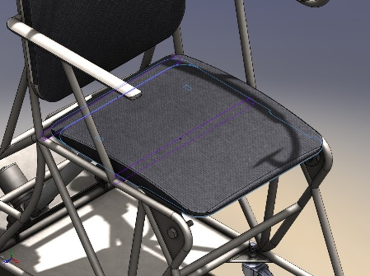  Rigid Connector-1
Rigid Connector-2 | Entities: 6 face(s)  Type: Rigid | 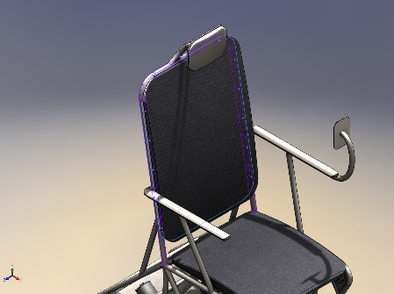  Rigid Connector-2
Rigid Connector-3 | Entities: 2 face(s)  Type: Rigid | 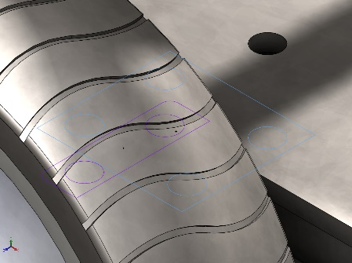  Rigid Connector-3
Rigid Connector-4 | Entities: 2 face(s)  Type: Rigid | 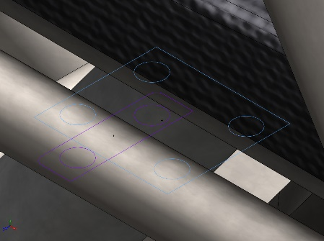  Rigid Connector-4

Pin/Bolt/Bearing Connector
Model Reference | Connector Details | Strength Details
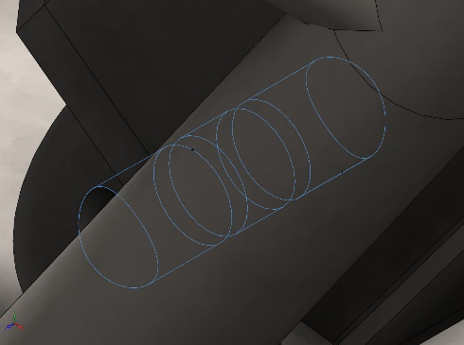  Pin Connector-1 | Entities: 3 face(s)  Type: Pin  With retaining ring (No translation): Yes  With key (No rotation): No  Connection Type: Distributed  Units: SI  Rotational stiffness value: 0 | No Data
Connector Forces Joint 1
Type | X-Component | Y-Component | Z-Component | Resultant
Axial Force (N) | -0 | -0 | -2.2874 | -2.2874
Shear Force (N) | -1.9738 | -5.4127 | 0 | 5.7614
Torque (N.m) | 0 | 0 | 4.7885e-14 | 4.7885e-14
Bending moment (N.m) | 0.016524 | 0.056506 | 0 | 0.058873

Connector Forces Joint 2
Type | X-Component | Y-Component | Z-Component | Resultant
Axial Force (N) | -0 | -0 | -8.1281 | -8.1281
Shear Force (N) | 5.2673 | 1.7594 | 0 | 5.5534
Torque (N.m) | 0 | 0 | 4.8463e-14 | 4.8463e-14
Bending moment (N.m) | -0.011985 | 0.090652 | 0 | 0.091441

Connector Forces Joint 3
Type | X-Component | Y-Component | Z-Component | Resultant
Axial Force (N) | 0 | 0 | 8.1281 | 8.1281
Shear Force (N) | -5.2673 | -1.7594 | 0 | 5.5534
Torque (N.m) | 0 | 0 | 4.4326e-14 | 4.4326e-14
Bending moment (N.m) | -0.0048462 | -0.040265 | 0 | 0.040556

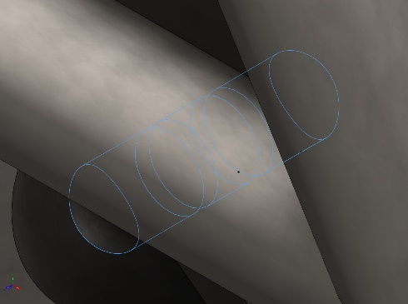  Pin Connector-2 | Entities: 3 face(s)  Type: Pin  With retaining ring (No translation): Yes  With key (No rotation): No  Connection Type: Distributed  Units: SI  Rotational stiffness value: 0 | No Data
Connector Forces Joint 1
Type | X-Component | Y-Component | Z-Component | Resultant
Axial Force (N) | -0 | -0 | -6.2324 | -6.2324
Shear Force (N) | -4.1864 | -1.2741 | 0 | 4.376
Torque (N.m) | 0 | 0 | 5.1269e-14 | 5.1269e-14
Bending moment (N.m) | 0.0047929 | 0.020975 | 0 | 0.021516

Connector Forces Joint 2
Type | X-Component | Y-Component | Z-Component | Resultant
Axial Force (N) | -0 | -0 | -6.2324 | -6.2324
Shear Force (N) | -4.1864 | -1.2741 | 0 | 4.376
Torque (N.m) | 0 | 0 | 5.4082e-14 | 5.4082e-14
Bending moment (N.m) | 0.0074695 | -0.061265 | 0 | 0.061719

Connector Forces Joint 3
Type | X-Component | Y-Component | Z-Component | Resultant
Axial Force (N) | 0 | 0 | 1.308 | 1.308
Shear Force (N) | -1.0284 | -4.0258 | 0 | 4.1551
Torque (N.m) | 0 | 0 | 5.3767e-14 | 5.3767e-14
Bending moment (N.m) | -0.012048 | -0.037041 | 0 | 0.038951

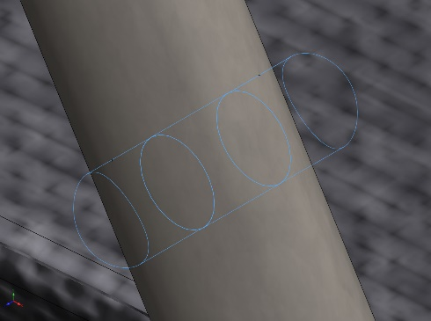  Pin Connector-3 | Entities: 3 face(s)  Type: Pin  With retaining ring (No translation): Yes  With key (No rotation): No  Connection Type: Distributed  Units: SI  Rotational stiffness value: 0 | No Data
Connector Forces Joint 1
Type | X-Component | Y-Component | Z-Component | Resultant
Axial Force (N) | -0 | -0 | -2.388 | -2.388
Shear Force (N) | 8.1801 | 5.7623 | 0 | 10.006
Torque (N.m) | 0 | 0 | 9.789e-14 | 9.789e-14
Bending moment (N.m) | -0.0019879 | -0.018697 | 0 | 0.018803

Connector Forces Joint 2
Type | X-Component | Y-Component | Z-Component | Resultant
Axial Force (N) | -0 | -0 | -2.388 | -2.388
Shear Force (N) | 8.1801 | 5.7623 | 0 | 10.006
Torque (N.m) | 0 | 0 | 9.3749e-14 | 9.3749e-14
Bending moment (N.m) | -0.054848 | 0.09938 | 0 | 0.11351

Connector Forces Joint 3
Type | X-Component | Y-Component | Z-Component | Resultant
Axial Force (N) | 0 | 0 | 2.7904 | 2.7904
Shear Force (N) | 5.8166 | 5.1596 | 0 | 7.7752
Torque (N.m) | 0 | 0 | 8.5747e-14 | 8.5747e-14
Bending moment (N.m) | -0.0023396 | 0.021277 | 0 | 0.021406

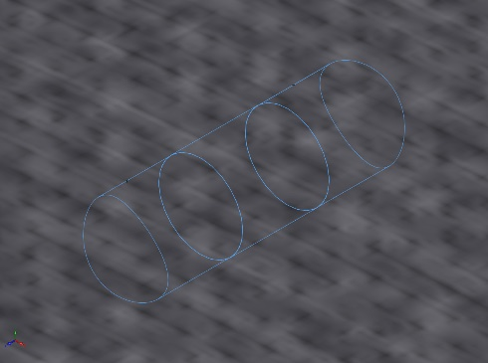  Pin Connector-4 | Entities: 3 face(s)  Type: Pin  With retaining ring (No translation): Yes  With key (No rotation): No  Connection Type: Distributed  Units: SI  Rotational stiffness value: 0 | No Data
Connector Forces Joint 1
Type | X-Component | Y-Component | Z-Component | Resultant
Axial Force (N) | -0 | -0 | -2.2071 | -2.2071
Shear Force (N) | 4.6516 | 3.8315 | 0 | 6.0264
Torque (N.m) | 0 | 0 | 8.5446e-14 | 8.5446e-14
Bending moment (N.m) | 0.0011299 | -0.017121 | 0 | 0.017158

Connector Forces Joint 2
Type | X-Component | Y-Component | Z-Component | Resultant
Axial Force (N) | -0 | -0 | -1.7826 | -1.7826
Shear Force (N) | -6.314 | -4.2446 | 0 | 7.6081
Torque (N.m) | 0 | 0 | 9.1797e-14 | 9.1797e-14
Bending moment (N.m) | 0.039748 | -0.076997 | 0 | 0.086651

Connector Forces Joint 3
Type | X-Component | Y-Component | Z-Component | Resultant
Axial Force (N) | 0 | 0 | 1.7826 | 1.7826
Shear Force (N) | 6.314 | 4.2446 | 0 | 7.6081
Torque (N.m) | 0 | 0 | 9.4756e-14 | 9.4756e-14
Bending moment (N.m) | 0.001432 | 0.015739 | 0 | 0.015804

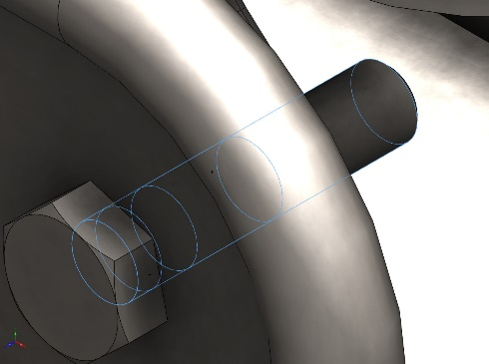  Pin Connector-5 | Entities: 3 face(s)  Type: Pin  With retaining ring (No translation): Yes  With key (No rotation): No  Connection Type: Distributed  Units: SI  Rotational stiffness value: 0 | No Data
Connector Forces Joint 1
Type | X-Component | Y-Component | Z-Component | Resultant
Axial Force (N) | 0 | 0 | 11.762 | 11.762
Shear Force (N) | 9.8664 | 59.092 | 0 | 59.91
Torque (N.m) | 0 | 0 | 1.6463e-13 | 1.6463e-13
Bending moment (N.m) | -0.84367 | 0.14284 | 0 | 0.85567

Connector Forces Joint 2
Type | X-Component | Y-Component | Z-Component | Resultant
Axial Force (N) | 0 | 0 | 20.411 | 20.411
Shear Force (N) | -51.489 | -255.28 | 0 | 260.42
Torque (N.m) | 0 | 0 | 1.689e-13 | 1.689e-13
Bending moment (N.m) | 3.0456 | -0.6975 | 0 | 3.1244

Connector Forces Joint 3
Type | X-Component | Y-Component | Z-Component | Resultant
Axial Force (N) | -0 | -0 | -20.411 | -20.411
Shear Force (N) | 51.489 | 255.28 | 0 | 260.42
Torque (N.m) | 0 | 0 | 1.3824e-13 | 1.3824e-13
Bending moment (N.m) | 1.8126 | -0.28236 | 0 | 1.8344

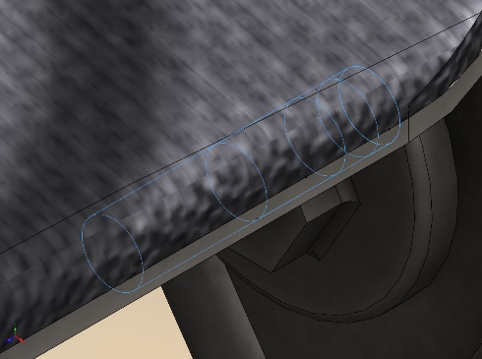  Pin Connector-6 | Entities: 3 face(s)  Type: Pin  With retaining ring (No translation): Yes  With key (No rotation): No  Connection Type: Distributed  Units: SI  Rotational stiffness value: 0 | No Data
Connector Forces Joint 1
Type | X-Component | Y-Component | Z-Component | Resultant
Axial Force (N) | 0 | 0 | -12.016 | 12.016
Shear Force (N) | 7.8852 | 61.841 | 0 | 62.342
Torque (N.m) | -0 | -0 | 1.6754e-13 | -1.6754e-13
Bending moment (N.m) | 0.88435 | -0.11131 | 0 | 0.89133

Connector Forces Joint 2
Type | X-Component | Y-Component | Z-Component | Resultant
Axial Force (N) | 0 | 0 | -20.584 | 20.584
Shear Force (N) | -55.616 | -262.09 | 0 | 267.92
Torque (N.m) | -0 | -0 | 1.7168e-13 | -1.7168e-13
Bending moment (N.m) | -3.1296 | 0.74062 | 0 | 3.216

Connector Forces Joint 3
Type | X-Component | Y-Component | Z-Component | Resultant
Axial Force (N) | -0 | -0 | 20.584 | -20.584
Shear Force (N) | 55.616 | 262.09 | 0 | 267.92
Torque (N.m) | -0 | -0 | 1.4108e-13 | -1.4108e-13
Bending moment (N.m) | -1.8548 | 0.3171 | 0 | 1.8817

Mesh information
Mesh type | Mixed Mesh
Mesher Used: | Blended curvature-based mesh
Jacobian points for High quality mesh | 16 Points
Jacobian check for shell | Off
Maximum element size | 99.1703 mm
Minimum element size | 4.95852 mm
Mesh Quality | High

Study Results

Name | Type | Min | Max
Stress1 | VON: von Mises Stress | 0.000e+00N/m^2  Node: 9285 | 4.447e+07N/m^2  Node: 409851
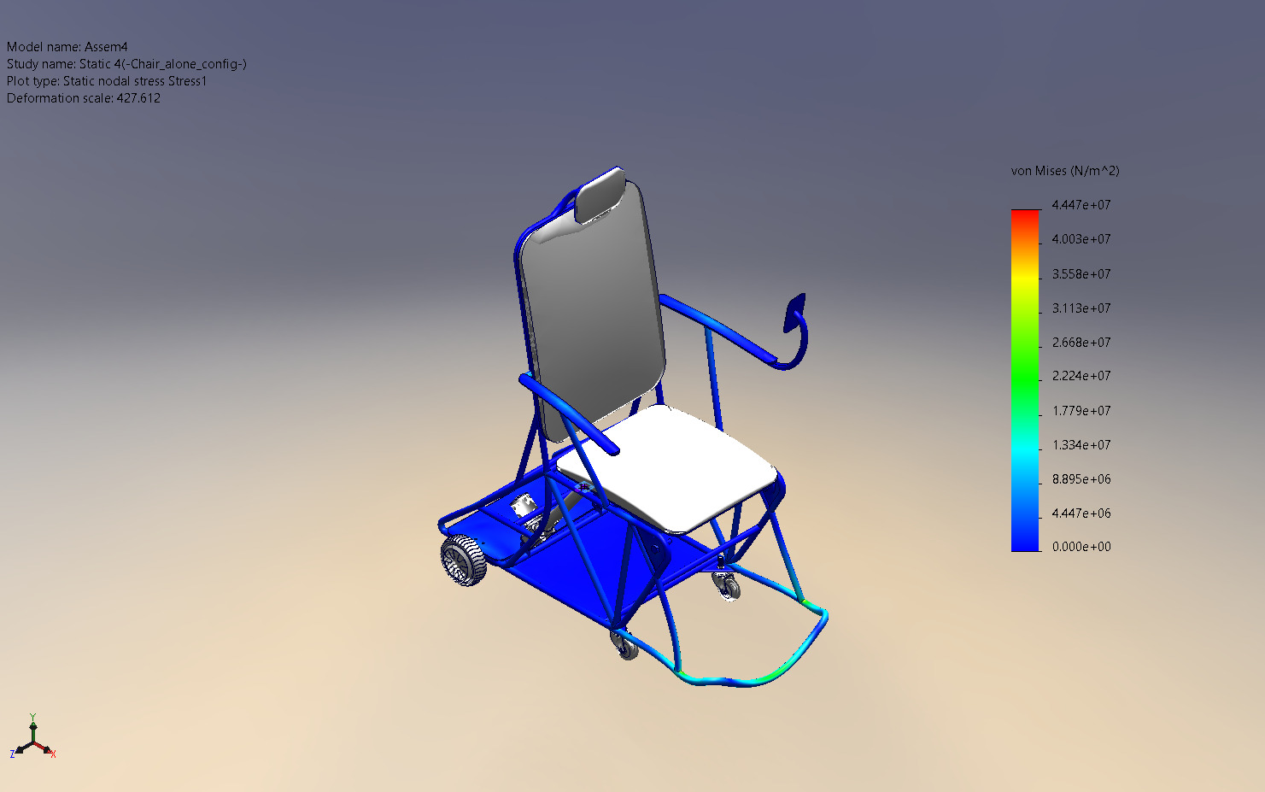
Assem4-Static 4-Stress-Stress1

Name | Type | Min | Max
Displacement1 | URES: Resultant Displacement | 0.000e+00mm  Node: 20338 | 3.567e-01mm  Node: 234488
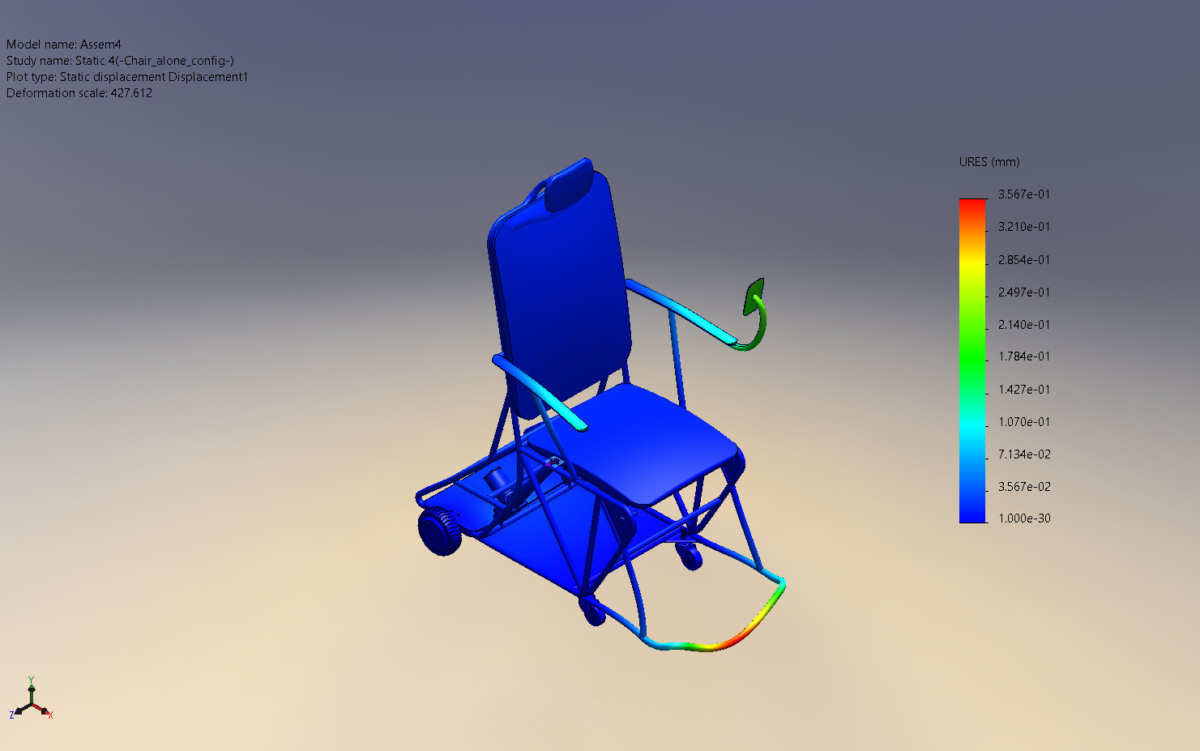
Assem4-Static 4-Displacement-Displacement1

Name | Type | Min | Max
Strain1 | ESTRN: Equivalent Strain | 0.000e+00  Element: 4608 | 1.118e-04  Element: 172373
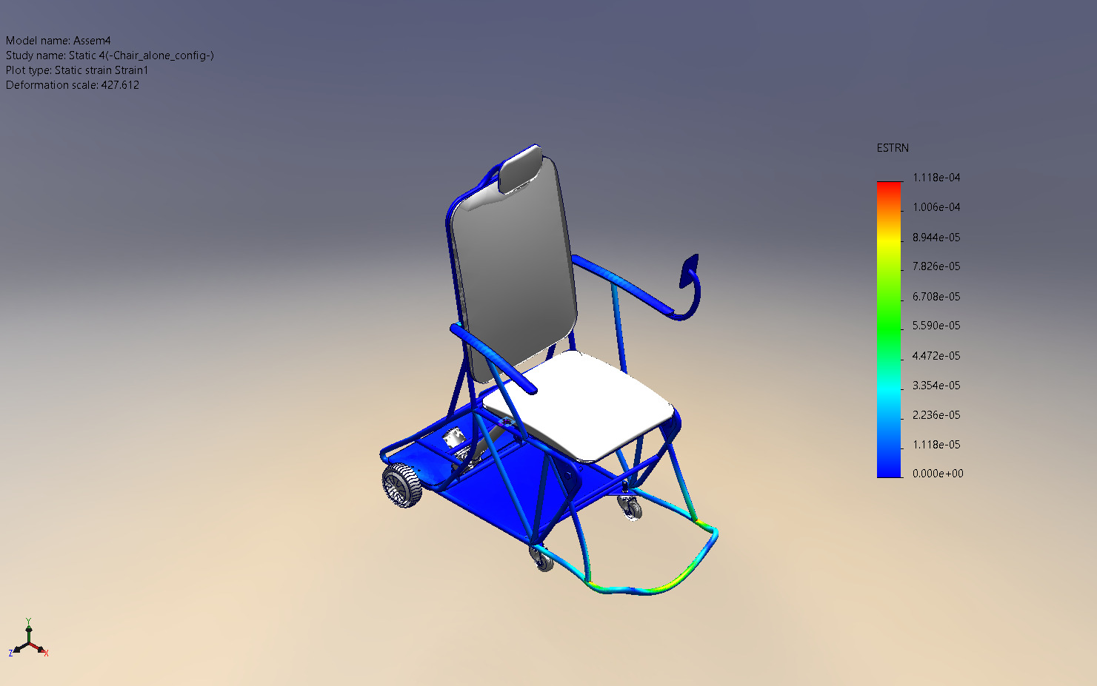
Assem4-Static 4-Strain-Strain1

Name | Type | Min | Max
Factor of Safety1 | Automatic | 6.356e+00  Node: 409851 | 1.000e+16  Node: 16854
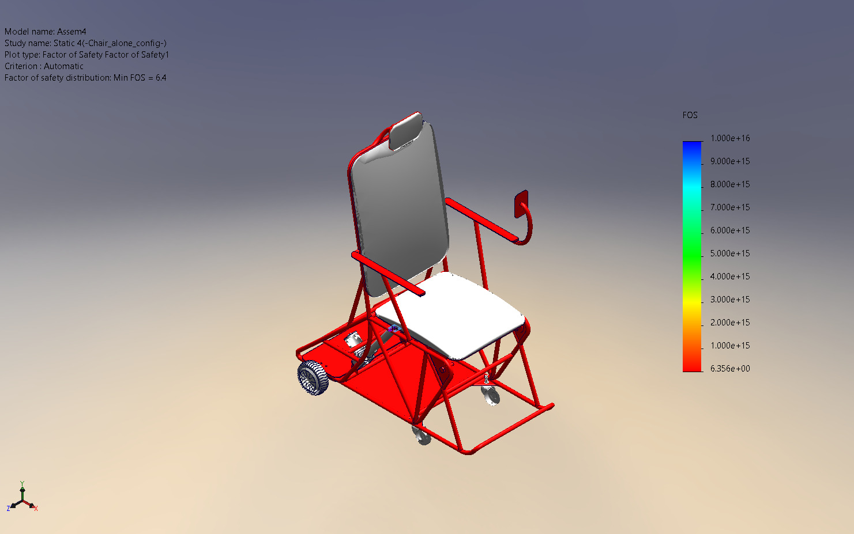
Assem4-Static 4-Factor of Safety-Factor of Safety1

Conclusion

